Pointe South Elementary School Uniform Policy
Pointe South Elementary School has a mandatory uniform dress code for the 2019-20 school year. Every grade level including Pre-K students are required to wear the outlined school uniform below.
In an effort to continue to promote a safe learning environment, students are to wear the following specifics listed below: solid color shirts black, red, or white, with khaki or black bottoms (pants, shorts, or skirts). Belts are a required part of dress code requirements. Examples are shown below.
SHIRTS
must be SOLID black, red, or white collared Polo Style or button-down shirts.
PANTS/SHORTS/SKIRTS
must be Khaki or Black. (No denim or denim like pants).

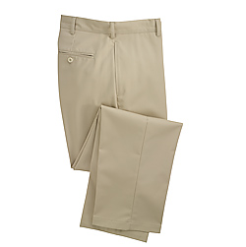
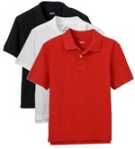
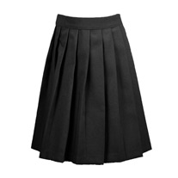

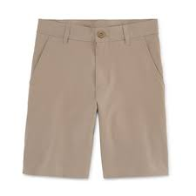
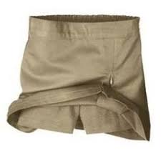

***Special NOTE: The following will not be permissible per the dress code in CCPS Student Handbook: pull over hoodies, cut off/frayed, or tight shorts; skinny style, tights, jeans, or stretch pants. For female students, shorts or skirts must not be shorter than 3 inches above the bend of the knee.

